

Horse riding school
CS314 / College of Computer & Cyber Sciences
Spring 2022-2023
May 2023

Horse Riding School

Simplified School System

Presented By:
Nada Khan 4210165
Bshayer Al Sharif 4210396
Rewaa Al Sharif 4110191

Dept. of Computer & Cyber Sciences
Faculty of Computer Science and Information Technology
University of Prince Mugrin Bin Abdulaziz, Madinah KSA
I. CONTACT INFORMATION
This project’s report is submitted to the Department of Computer & Cyber Science at Prince Mugrin Bin Abdulaziz University in partial fulfillment of the requirements for the Web Application Development Course (CS314).

Authors: Nada Khan 4210165@upm.edu.sa Bshayer Al Sharif 4210396@upm.edu.sa
Rewaa Al Sharif 4110191@upm.edu.sa

Supervisors:

Ms. Marwa Alrehaili

___________________________________________________________________________________
Dept. of Computer & Cyber Sciences Internet: http://um.edu.sa
Faculty of Computer Science and Information Technology Phone: +966 50 091 4440
University of Prince Mugrin
Kingdom of Saudi Arabia
II. INTELLECTUAL PROPERTY RIGHT DECLARATION
This is to declare that the work under the supervision of Ms. Marwa Alrehaili having title “Horse Riding School” carried out in partial fulfillment of the requirements of the Web Application Development course (CS314), is the sole property of the University of Prince Mugrin Bin Abdulaziz and the respective supervisor and is protected under the intellectual property right laws and conventions. It can only be considered/ used for purposes like extension for further enhancement, product development, adoption for commercial/organizational usage, etc., with the permission of the University and respective supervisor.

The above statement applies to all students and faculty members.
Date: 05-06-2023

Authors:
Name: Nada Khan Signature: 4210165

Name: Bshayer Al Sharif Signature: 4210396

Name: Rewaa AL Sharif Signature: 4110191

Supervisors:
Name: Ms. Marwa Alrehaili Signature: _____________________

III. ANTI-PLAGIARISM DECLARATION
This is to declare that the above publication produced under the supervision of Ms. Marwa Alrehaili having title “Horse Riding School” is the sole contribution of the author’s and no part here has been reproduced illegally (cut and paste) which can be considered as Plagiarism. All referenced parts have been used to argue the idea and have been cited properly. We will be responsible and liable for any consequence if violation of this declaration is proven.

Date: 05-06-2023

Authors:
Name: Nada Khan Signature: 4210165

Name: Bshayer Al Sharif Signature: 4210396

Name: Rewaa AL Sharif Signature: 4110191

- ACKNOWLEDGEMENT
In the accomplishment of this project successfully, we are filled with gratitude that we have completed the project within the scheduled time which is about “Horse Riding School”. Two members of our team are employees in a stable; one is a manager and the other is a trainer. We decided to use the knowledge and skills we acquired in this course to create a website for the stable. In this database we add information and delete as we like as adminstator it is a database website. Also, we would like to express our respect & gratitude to our teammates for their support in succeeding in completing our project. Finally, we would like to thank our supervisor Ms. Marwa Alrehaili whose valuable guidance has been the one that assisted us manage this project and make it full success. Her suggestions and their instructions have served as a major contributor towards the completion of the project.

- ABSTRACT
- HorseshowPro Management System is an open-source software tool designed to simplify the process of organizing and managing horse shows. The system provides an intuitive interface for managing all aspects of a horse show, from selecting and preparing the venue, to coordinating with vendors, to registering competitors, to tracking results and awarding prizes.
- Built using the Python/Django framework, HorseshowPro Management System automates many of the manual tasks involved in organizing a horse show, making the process faster, easier, and more efficient. With its powerful features and user-friendly design, it is quickly becoming a
- favorite among horse show organizers worldwide.
- Whether you are a professional event organizer or simply someone interested in organizing a horse show for your local community, HorseshowPro Management System can help simplify the process and ensure that your event runs smoothly.
- HorseshowPro Management System offers a range of modules to help manage all aspects of a horse show. The venue management module helps with selecting and preparing the venue, including managing facilities, scheduling practice rides, and coordinating equipment rentals.
- The vendor management module helps coordinate with various vendors involved in the event, such as feed suppliers, farriers, and veterinarians. The competitor management module allows for easy registration of competitors, tracking of entries and fees, and generation of ride schedules.
- The scheduling module helps create and manage the schedule of events, including warm-up and practice rides, and shows a real-time view of scheduled events. Finally, the result tracking module allows for easy management of competition results, awarding of prizes, and generation of reports.
- Overall, HorseshowPro Management System provides a comprehensive solution for organizing and managing horse shows, helping to reduce the workload of organizers, minimize errors, and ensure a smooth and successful event.

Keywords:
Stable: it is a building in which livestock, especially horses, are kept.

V. TABLE OF CONTENTS
1.1.1 CHAPTER 1 – INTRODUCTION
Chapter 1 INTRODUCTION
1.1 Purpose of the Project
1.2 Purpose of this Document
1.3 Overview of this Document
1.4 Existing System
1.4.1 Existing system description
1.4.2 Problems in the existing system

1.1.2 CHAPTER 2 – SYSTEM ANALYSIS Chapter 2 SYSTEM ANALYSIS
2.1 Data Analysis
2.1.1 Data Flow Diagrams
2.1.2 System Requirements

2.1.2.1 Clients, Customer, and Users 2.1.2.2 Functional and Data Requirements 2.1.2.3 Non-functional Requirements

2.1.2.3.1 Look and Feel Requirements 2.1.2.3.2 Usability Requirements 2.1.2.3.3 Security Requirements 2.1.2.3.4 Performance Requirement 2.1.2.3.5 Portability Requirements
2.1.3 Proposed Solutions
2.1.4 Alternative Solutions

1.1.3 CHAPTER 3 – DESIGN CONSIDERATIONS Chapter 3 DESIGN CONSIDERATIONS
3.1 Design Constraints
3.1.1 Hardware and Software Environment
3.1.2 End-user Characteristics
3.2 Architectural Strategies
3.2.1 Algorithm to be used
3.2.2 Reuse of Existing Software Components
3.2.3 Project Management Strategies
3.2.4 Development Method 3.2.5 Future Enhancements/Plans

1.1.4 CHAPTER 4 – SYSTEM DESIGN Chapter 4 SYSTEM DESIGN
4.1 System Architecture and Program Flow

4.1.1 Major Modules 4.1.2 Sub Modules
4.2 Detailed System Design
4.2.1 Detailed Component Description

1.1.5 CHAPTER 5 – IMPLEMENTATION AND VALIDATION Chapter 5 IMPLEMENTATION AND VALIDATION
5.1 Appendix A Code

1.1.6 APPENDICES
Appendix A CODE
Appendix References

VII. LIST OF FIGURES Figure 2.1. Zero level of Data Flow Diagram of Club Management System 12
Figure 2.2. User Registration Data Flow of Club Horse riding school 12
Figure 2.3. User Login Data Flow of Horse Riding School 13
Figure 2.4. User Comment Activity of Horse riding school 13
Figure 2.5. User Registration Activity of Horse riding school 14
Figure 4.1. System Architecture of Horse riding school 21
Figure 4.3 Use Case Diagram Representing the Entire Function of the System 22

CHAPTER 1

HorseshowPro Management System Project Proposal
Introduction:
Horse shows are increasingly popular events that showcase the skills of both riders and horses. However, organizing a horse show can be a challenging and time-consuming task, with a variety of logistical details to manage. To help address this challenge, we propose the development of HorseshowPro Management System, an open-source software tool designed to simplify the process of organizing and managing horse shows.

Objective:
The objective of the HorseshowPro Management System is to provide a comprehensive solution for organizing and managing horse shows. The system will automate many of the manual tasks involved in organizing a
horse show, making the process faster, easier, and more efficient. It will provide a user-friendly interface for managing all aspects of a horse show, from selecting and preparing the venue, to coordinating with vendors, to registering competitors, to tracking results and awarding prizes.

Scope:
The scope of HorseshowPro Management System includes the following modules: venue management, vendor management, competitor management, scheduling, and result tracking. Each module will provide a range of features to help manage its respective aspect of the horse show. The system will be built using the Python/Django framework, which is known for its flexibility, scalability, and ease of use.

Target Audience:
The target audience for HorseshowPro Management System includes event organizers, horse trainers, barn managers, and anyone else involved in organizing and managing horse shows. The system will be designed to be accessible to users with varying levels of technical expertise, including those with no programming experience.

Methodology:
To develop HorseshowPro Management System, we will follow an iterative development approach, starting with a basic prototype and gradually adding new features and functionality over time. We will work closely with potential users of the system to ensure that it meets their needs and requirements. Testing and debugging will be an ongoing process throughout the development cycle.

Conclusion:
HorseshowPro Management System will provide a much-needed solution for organizing and managing horse shows, helping to simplify the process and ensure that events run smoothly. By automating many of the manual tasks involved in organizing a horse show, the system will save time and reduce errors, making it an essential tool for event organizers, trainers, and barn managers everywhere.

- INTRODUCTION
  - Purpose of the Project
We wanted to create a data base fitting to our stable . Since part of the team is a trainer and a stable manager we immediately figured that we must equip all this knowledge from the web course to create a web website fitting for our stable. And a usable database for usage during workdays to make organization easier for those who work in the stable. As computer students we must always use our coding knowledge to serve real world problems. We didn’t just want to make a project that no one would use after this course.
  - Purpose of this Document
The purpose of this document is to provide a high-level overview of the system. There will be a thorough study of the system that demonstrates the flow of our work in order to comprehend the components, structure, and needs of our system, as well as a detailed explanation of each component. It also provides a high-level overview of the website's user interface so that the reader may get a sense of how it works.

  - Overview of this Document
This document is divided into two sections: one for documentation, explanation, and clarification, and the other for content presentation. The second section is divided into five chapters. Each one has its own thorough segment centered on a single concept. The table of contents aids in navigating through each chapter's pages. System analysis is included for better understanding to the system's components, structure, needs, and flow. Finally, the layout of the site and the code that was utilized to create it are shown in the final two chapters.

  - Existing System

1.4.1 Existing System Description
When talking about Horse Schools especially in the Arab world, they generally use the manual frame; They do not have an easy-to-use interface and they do not use the database to keep track of member and event records. Besides, the manual frame wastes a great deal of the cost of the office work, and it also wastes the problem of the addition room because they must have space to store all the records. Most of these school systems do not have a clear way to show the monthly or weekly updates of the events, and they usually change them manually.

1.4.2 Problems in the Existing System
We want to improve the website and add more pages and deploy it in a better form and we would like to expand databases. We want it to create multiple different accounts to lig in and sign up other than the admin.
CHAPTER 2
- SYSTEM ANALYSIS
2.1 Data Analysis

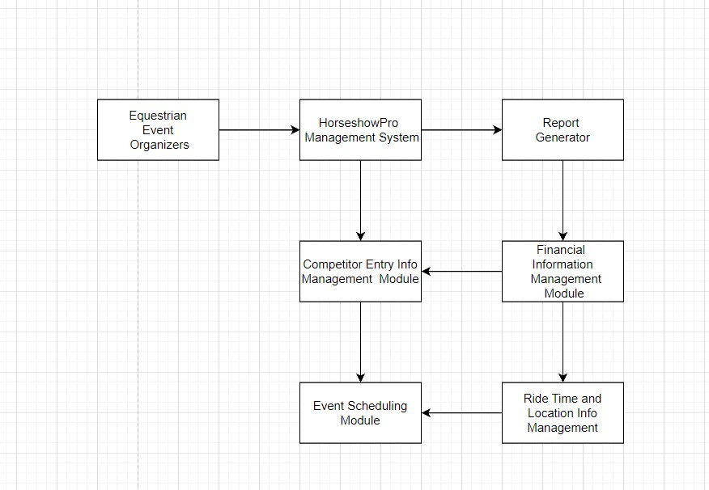
2.1.1 Data Flow Diagrams

Figure 2.1. Data flow diagram.

2.1.2 context diagram
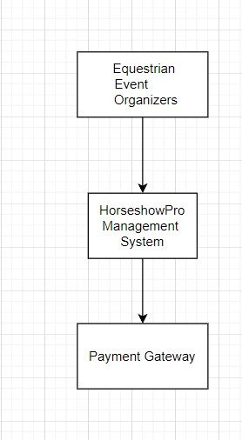

2.1.4 Activities Diagram
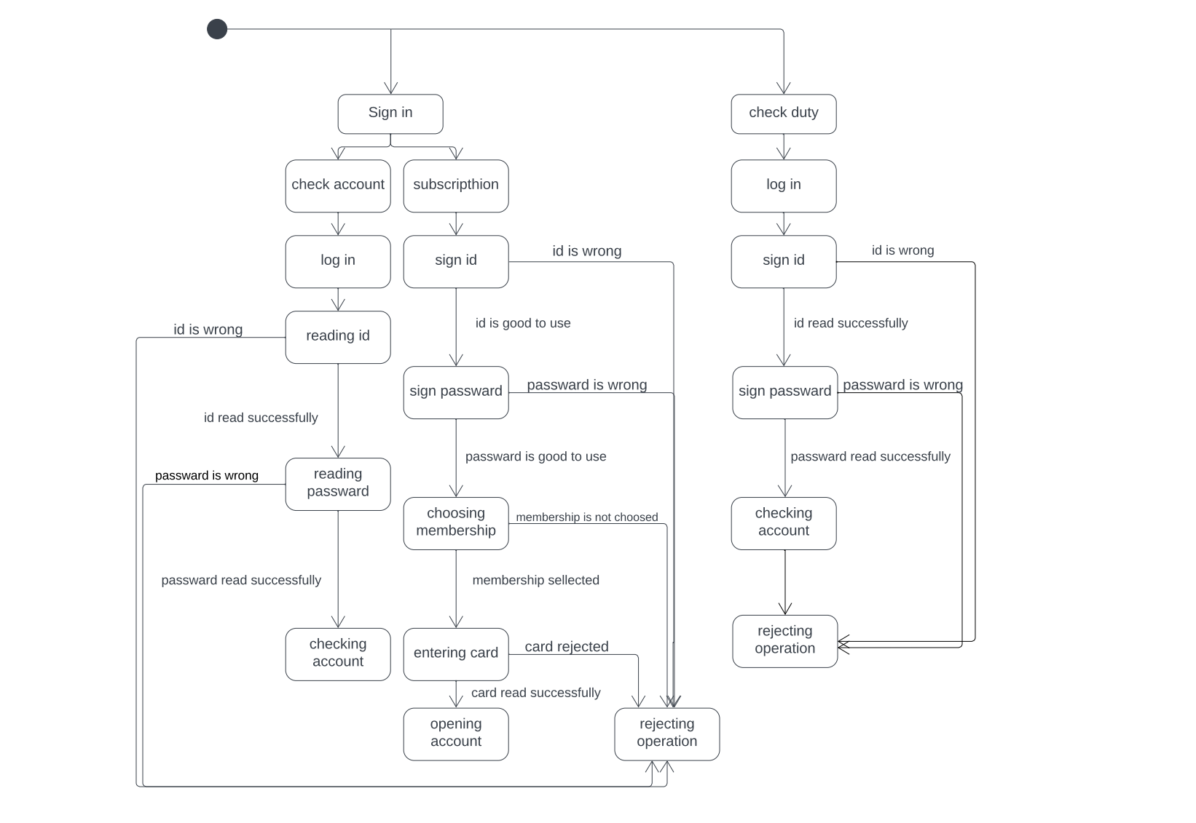

Figure 2.4. Activity.

2.1.2 System Requirements

2.1.2.1 Clients, Customer, and Users
- This website is created for women in order to organize their services in the stable.
- The user of the website can create user and admin control it.

2.1.2.2 Functional and Data Requirements
- Visitors:
    - All visitors shall be able to access the home page and view all data on it.
    - All visitors shall be able to click on READ MORE button on the home page and redirected to about page.
    - All visitors shall be able to register in order to have an account and be a member of the club via sign up page providing their username, email, and password.
    - All visitor's data shall be validated when they register their account using sign up page.
- Register:
  - The system shall provide the user with a friendly and simple interface to register, and a link in the same interface to login interface.
  - The system shall ask the user to provide their username, email, password and reenter the password while entering.
  - The system shall allow registration of many users with the same email. d- The system shall notify the user if the username that they entered is already exists. e- The system shall notify the user if the email that they entered has a wrong format. f- The system shall notify the user if the password that they entered is too common, or entirely numeric, or too short and it must contain at least 8 characters or it is too similar to the username.
  - The system shall notify the user if the re-entered password does not match the password.
  - The system shall notify the user in case of a missing field.
  - The system shall redirect the successfully new registered user to login page.
- Log in:
  - The system shall provide the registered user with friendly and simple interface to login, and a link in the same interface to sign up interface.
  - The system shall ask the user to enter their username and password to login. c- The system shall notify the user if the username that they entered does not exist. d- The system shall notify the user if the password that they entered is incorrect.
e- The system shall redirect the successfully logged in user to the home page.
- contact:
  - The system shall allow visitors and club members to send messages to administrator.
- Registered Club's members:
  - The club members shall be able to access the (GET YOUR FIRST TELESCOPE) page, view the PDF file that guides the members to possess their first telescope and download the file.
  - The Club members shall be able to like any blog post.
  - The Club members shall be able to comment on any blog post.
  - The Club members shall be able to view their profile page and edit their profile (add a picture, change their username and email).
  - The Club member shall be able to reset their password.
- Login:
a- The system shall allow the logged in users to log out of their account.
- Administration: a- The admin should be able to login to admin panel.
    - The admin should be able to access member's information, edit them and delete them.
    - The admin should be able to add new members.
    - The admin should be able to publish blog posts, NASA news, books, astronomical topics files and astronomical events.
    - The admin should be able to like and comment on members' blog posts.

2.1.2.3 Non-functional Requirements Usability Requirements a- User-Friendly:
Without difficulty, every user shall be able to use the website.
        - Security Requirements a- Confidentiality:
To protect the user's privacy, the system encrypts the password in the database.
b- Preventing HTTP Host header attacks:
The website should be protected from HTTP Host header attacks.
c. Using only HTTPS connection:
The website should offer only HTTPS connections and redirect all HTTP connections to HTTPS.
2.1.2.3.4 Performance Requirement a- Availability:
The website should be available 24/7.
b- Quality:
The system should never crash more than 0.5 min.
2.1.2.3.5 Portability Requirements a- the system should operate on different operating systems.
b- the system should operate on different browsers.

2.1.3 Proposed Solutions
This website shall make stables more organized and elevate elegance in working.

2.1.4 Alternative Solutions
The system should update regularly to accommodate and refresh.

- DESIGN CONSIDERATIONS 3.1 Hardware and software environment
3.1.1 Software Requirements:
User Interface:
      - PyCharm Editor.
      - The user interface and basic layout for the system was created using HTML.
      - All validations and client-side scripting features were created using Python and JavaScript.
      - The system's web pages has been designed using CSS.
Application:
      - Client on Internet: Web Browser, any Operating System.
      - Framework: Django
      - Database: SQLite
      - Markup Language: HTML, CSS • Scripting Language: Python, JavaScript.
3.1.2 Hardware Requirements:
      - Personal Computer.
      - Internet Connection.
  - The Economic Costs:
    - Hardware Cost:
      - Personal Computer 6500 RS.
      - Internet Subscription 700 RS/6 months
    - Software Cost:
      - PyCharm: Free.
      - Django: Free.
      - SQLite Database: Free.
      - Python: Free.
      - JavaScript: Free.

1.3 End User Characteristics
- Our project should be suitable for women.
- The goal of our project should be to organize data bases is stable.
- Our project should be easy and simple to use.
- The administrator and user should be able to enter and retrieve data with ease in our project.
- A good and user-friendly method of presenting and retrieving data is required for our project.
- Our project must perform well in terms of recording the login and password as well as receiving all the entered data.

3.4 Architectural Strategies

3.4.1 Reuse of Existing Software Components
We are building a website, so we are using existing software components to improve software quality and productivity. In designing and developing the website, we reused codes, for example, HTML code in the template of the website is taken from an open-source platform that provides free sits templates. the site also contains scientific astronomy topics in PDF format.

3.2.3 Project Management Strategies
# | Task | Duration | Deliverable
1 | Proposal | 1 Week | System Proposal
2 | Meet the Client | 1 Week
3 | Planning | 2 Weeks | System request
3.1 | Deliver System request | 2 Days
3.2 | Approve project | 3 Days
4 | Analysis | 2 Weeks | System Requirements
4.1 | Analyze similar systems | 4 Days
4.2 | Gather requirements | 1 Week
5 | Design | 2 Weeks | Database, Mock-up  Design
5.1 | Decide which software to use | 3 Days
5.2 | Create the database | 3 Days
5.3 | Create Mock-up designs for the web pages | 1 Week
6 | Meet the Client | 3 Days
7 | Review the mock-up design | 1 Week
8 | Implementation | 2 Weeks | Software

3.6 Development Method
Software reuse is the process of creating software systems from existing software rather than building them from scratch.

3.7 Future Enhancements/Plans
There are many ways this could be further improved:
Add backup/restore functionality.
Move to a better database backend and/or revamp the sql to be less nasty (not as much of a problem when we're not doing complex reports)
Help with fees, budgeting and journal entry (still a largely manual process)
A lot of reporting functionality was removed from this version just to streamline the github commit and maintenance/migration to a modern django version. The problem is that while show judges insist on using paper, there needs to be a translation layer to make it electronic. All that is really needed is to gather the current placings and danishes for each class but, with all the volunteers typically needed to make a Horseshow operate, this is impractical. We must, therefore, do without lots of other automation that could be used. If judgings are saved electronically, the following features could be restored:
Automatic qualifications reporting
Automatic medals scoring/tracking
Automatic highpoint scoring
Web-based (or external display) Highpoint leaderboard year/year comparasion reports

CHAPTER 4 4. SYSTEM DESIGN
4.1 System Architecture Diagram
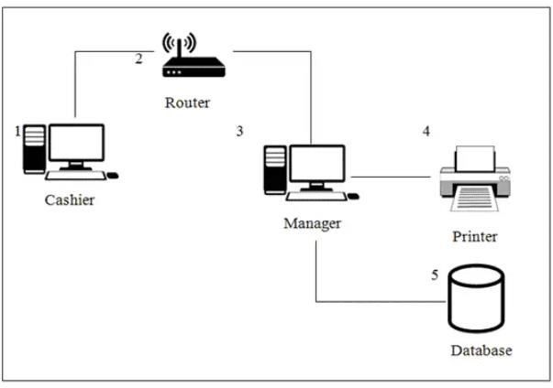

Figure 4.1. System Architecture

4.2 Use Case Diagram
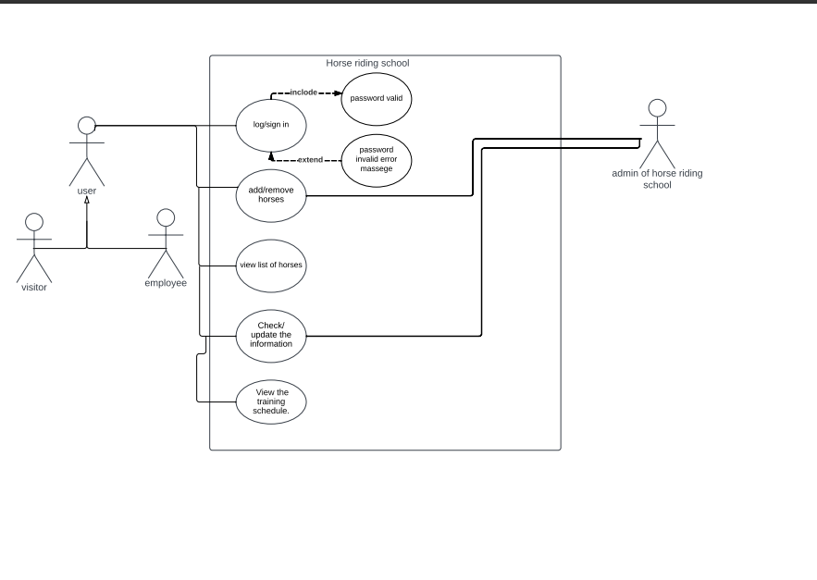

Figure 4.3 Use Case Diagram Representing the Entire Function of the System

1.1. Use Case Description
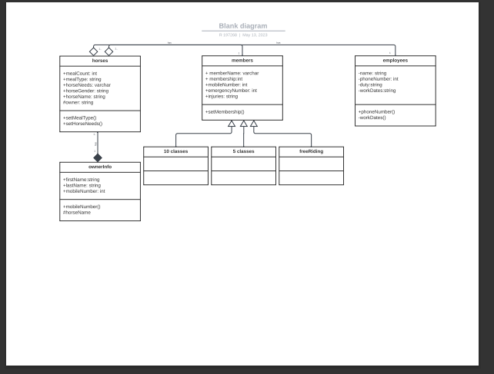

4.3 Database Schema
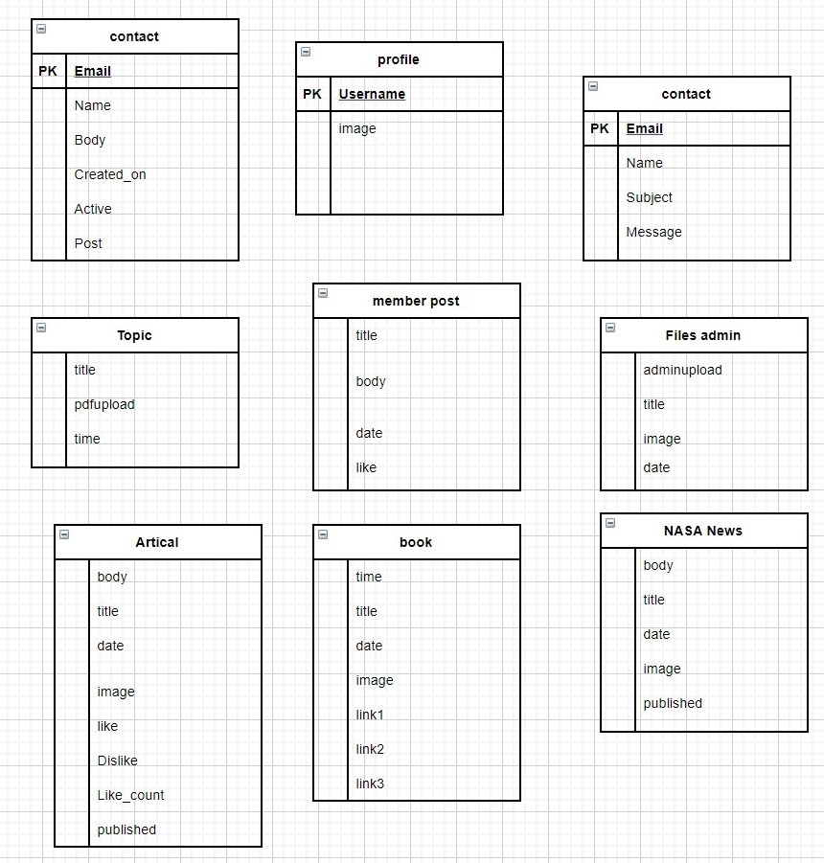
Figure 4.3 Database Schema Diagram of The System

CHAPTER 5
4.4 Mock-up Design

4.4.1 Home Page 

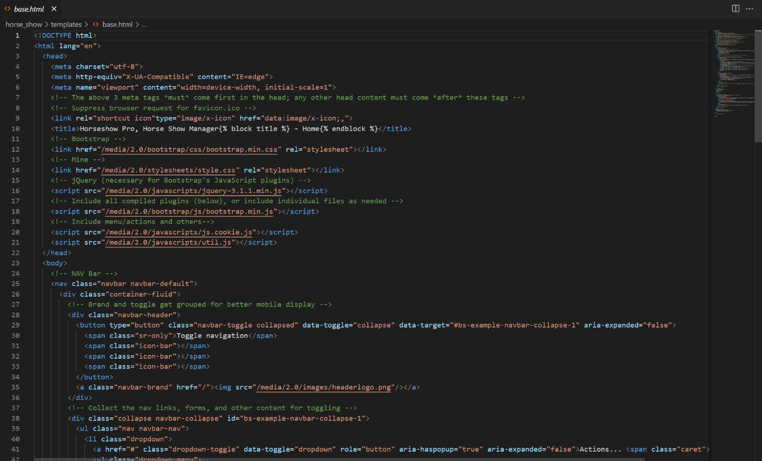
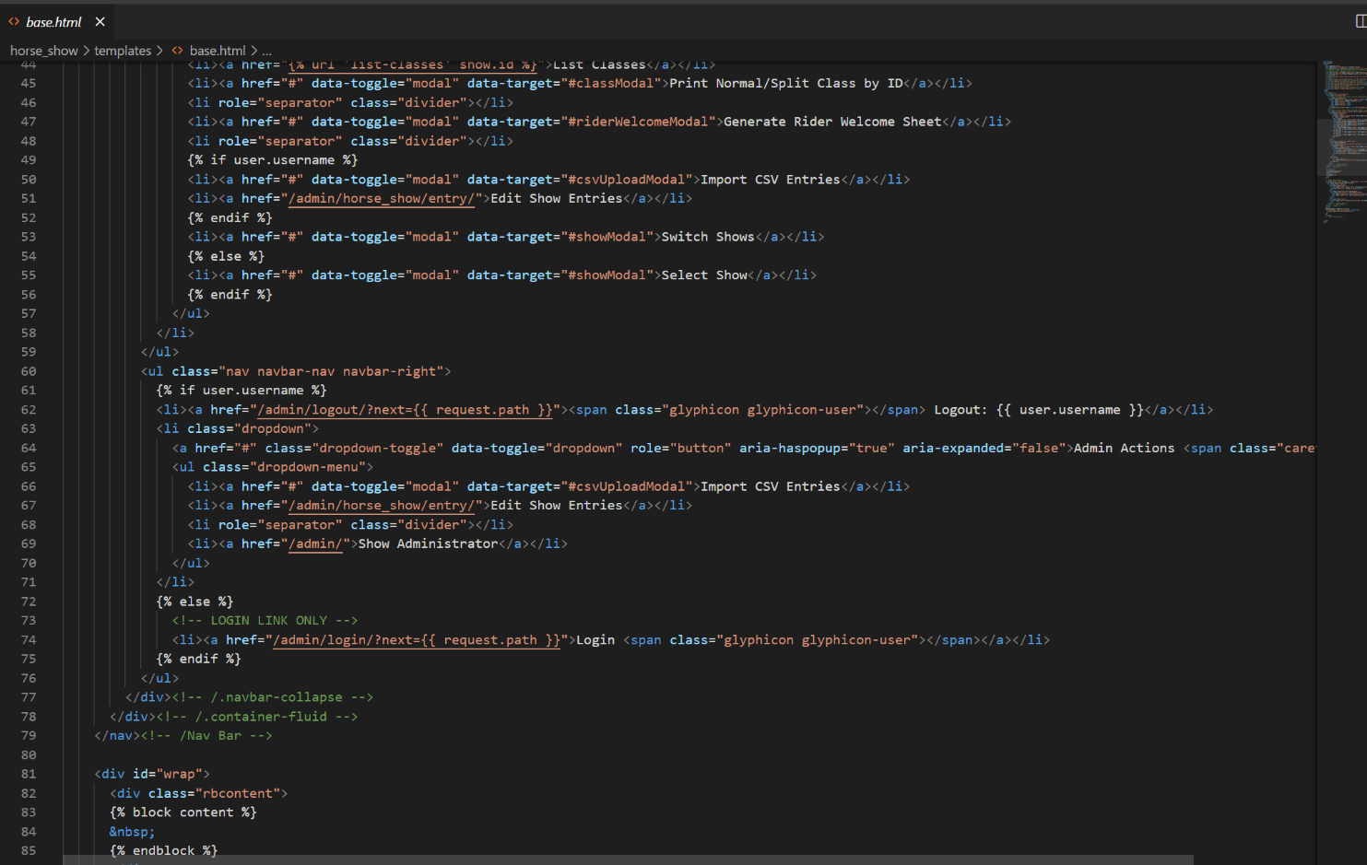

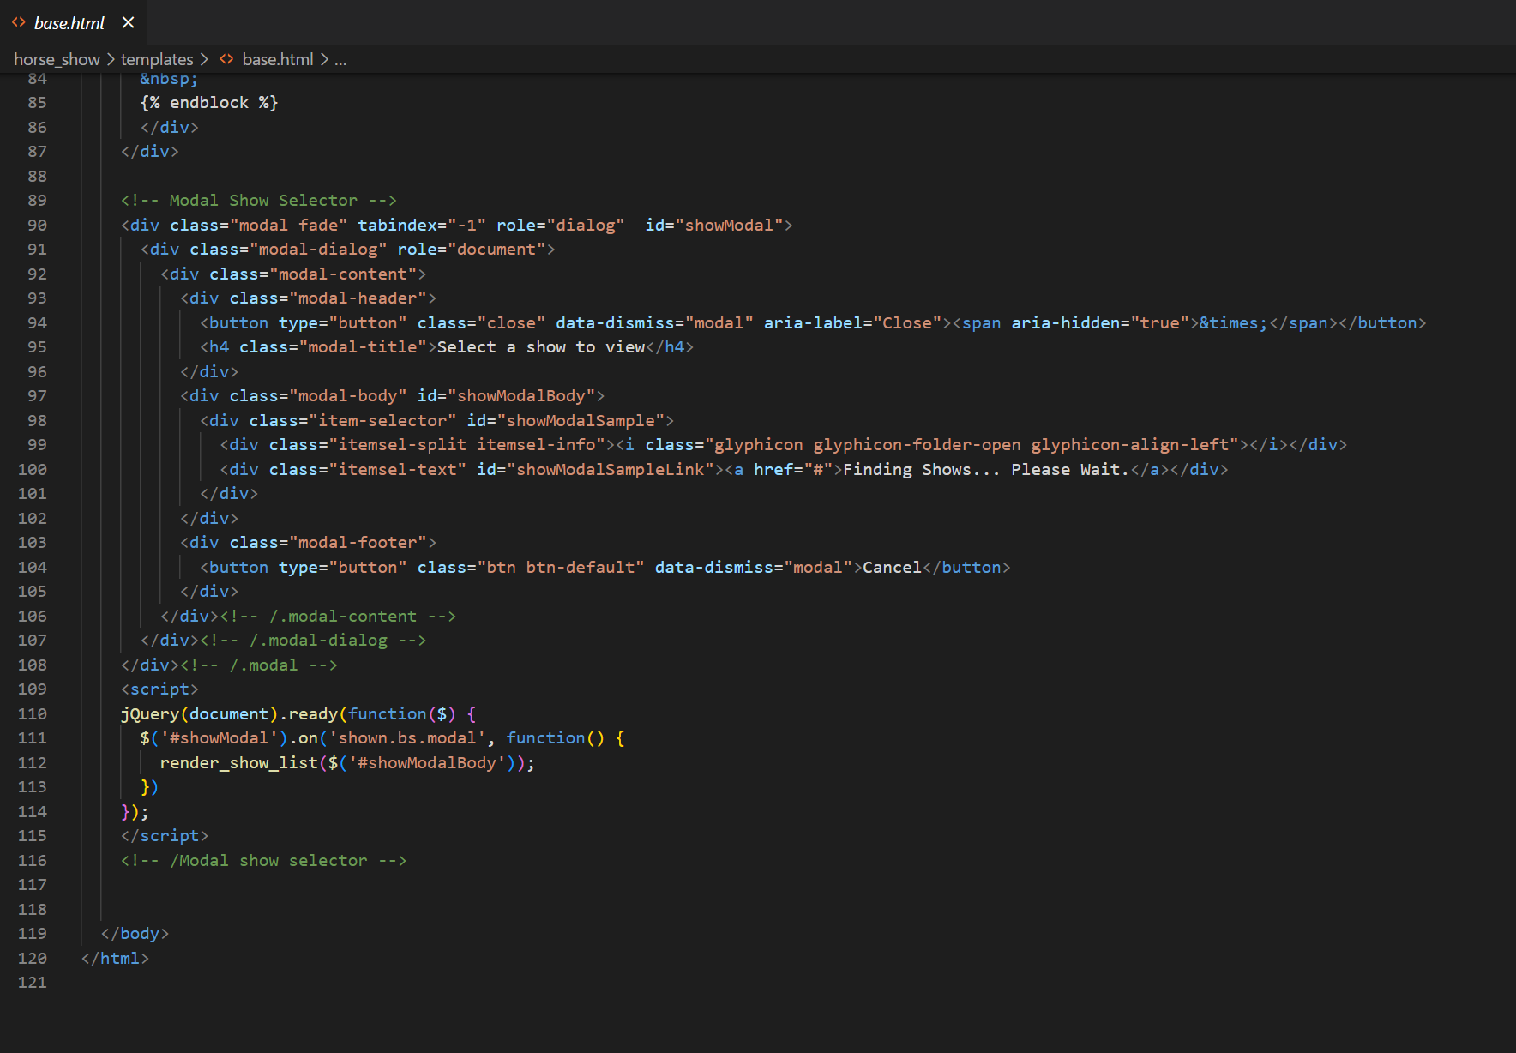

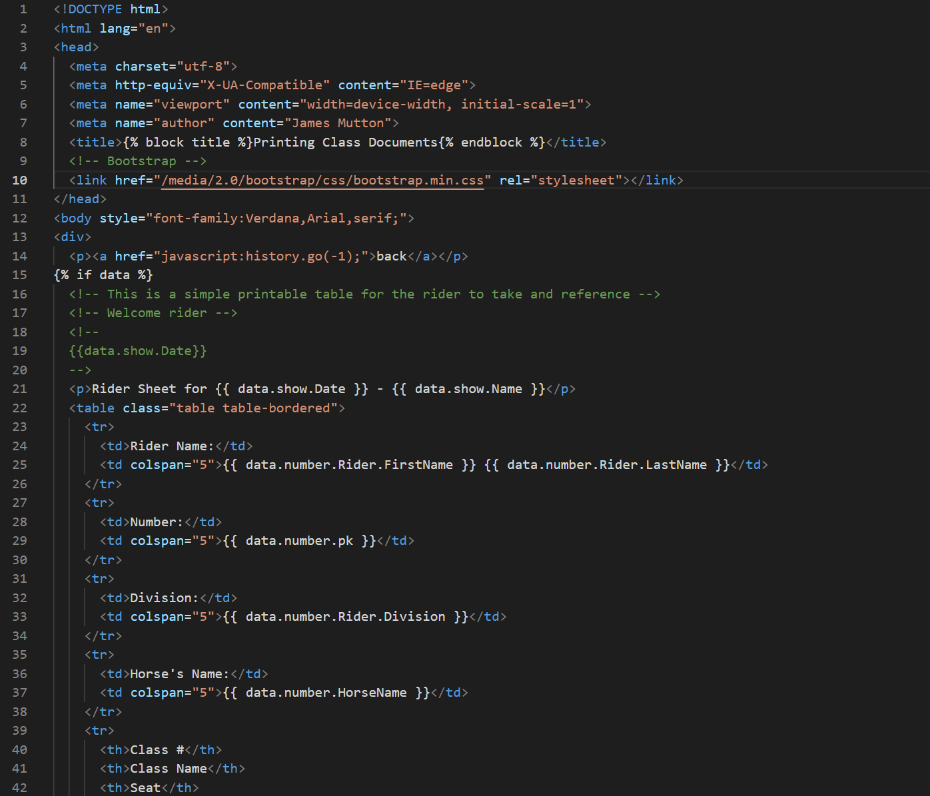

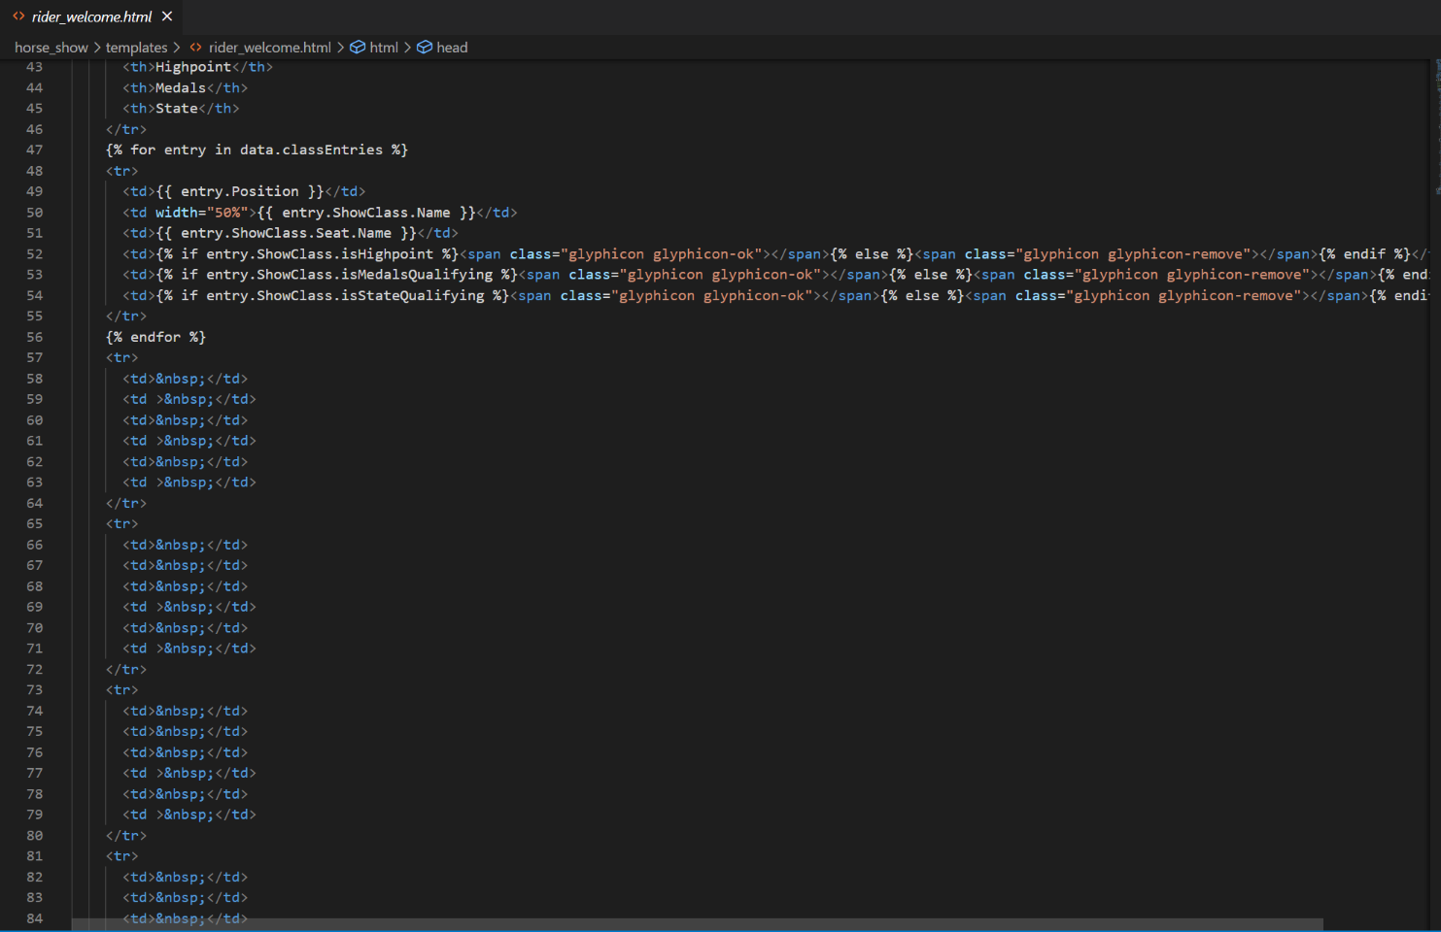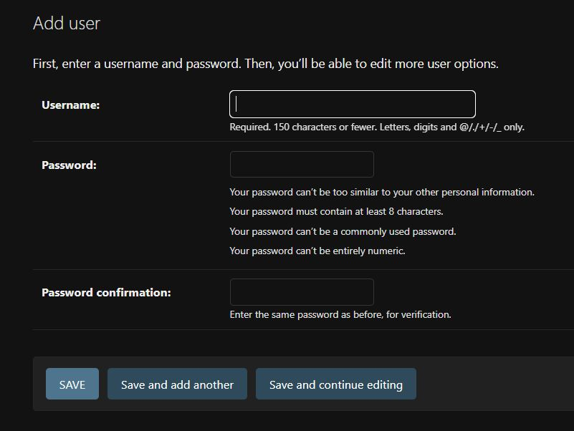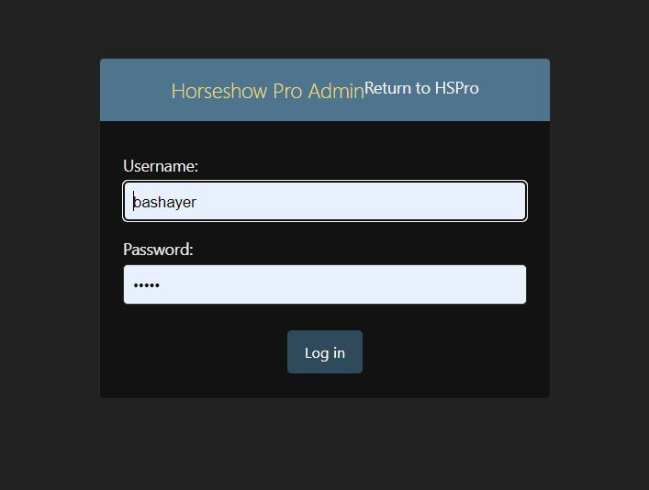

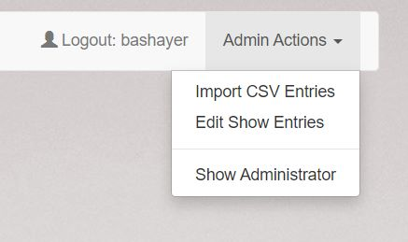
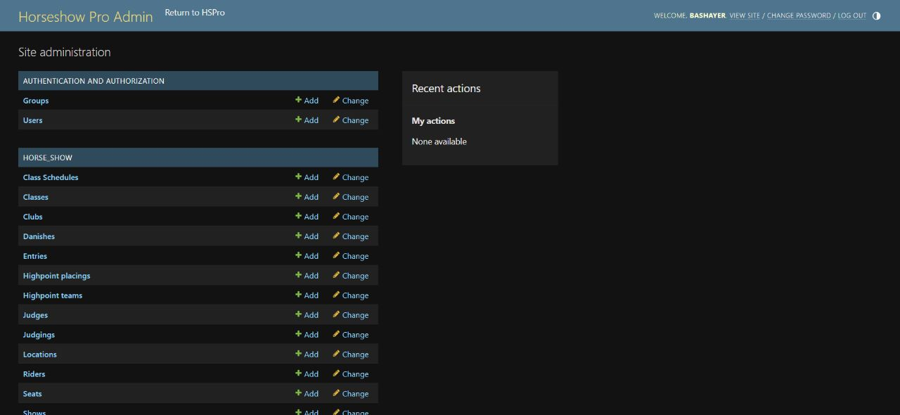

HorseshowPro Management System Project Modules
HorseshowPro Management System will consist of the following modules:

- Venue Management Module:
This module will allow users to manage the venue for the horse show, including selecting and preparing the location, managing facilities, scheduling practice rides, and coordinating equipment rentals.

- Vendor Management Module:
This module will provide tools to help users coordinate with various vendors involved in the event, such as feed suppliers, farriers, and veterinarians. It will also help manage vendor payments and invoices.

- Competitor Management Module:
This module will allow users to easily register competitors, track entries and fees, and generate ride schedules. It will also provide tools to manage competitor information, including rider and horse names, breeds, and ages.

- Scheduling Module:
This module will help create and manage the schedule of events for the horse show, including warm-up and practice rides. Users will be able to view a real-time schedule of upcoming events and make updates as needed.

- Result Tracking Module:
This module will allow users to easily manage competition results, award prizes, and generate reports. It will provide tools to track scores, times, and other relevant information for each event, as well as tools to manage prize money and awards.

Each module will be designed to work seamlessly with the others, providing an integrated solution for organizing and managing horse shows. The system will be flexible enough to meet the needs of differe nt types of events, from small local competitions to large-scale international shows.

HorseshowPro Management System Thesis – Methodology
- Methodology
- System Development Life Cycle (SDLC)
- Extreme Programming Methodology
- Use Case Model
- Buy Product Use Case Description of DLT HorseshowPro -Payroll Management System
- Activity Diagram
- Context Diagram
- Data Flow Diagram
- Entity Relationship Diagram
- Data Dictionaries
- Screen Design
- System Requirements
- Hardware Requirements

METHODOLOGY
The development methodology for HorseshowPro Management System will involve several steps, including:
- Requirements gathering: In this phase, the project team will work with stakeholders to gather and document requirements for the system, including key features, functionality, and performance requirements.
- Design: Based on the requirements gathered in the previous step, the project team will design the overall architecture of the system, including the modules and components that will make up the final product. The team will also develop wireframes and interface designs for the user interface.
- Development: In this phase, the project team will develop the software code for the system using the Python/Django framework. Each module and component will be built and tested separately before being integrated into the final product.
- Testing: Following development, the system will undergo rigorous testing to ensure that it meets all performance and functional requirements. This will include both automated and manual testing, as well as usability testing to validate the user interface.
- Deployment: Once testing is complete, the system will be deployed to a production environment, either on-premises or in the cloud. The project team will provide support during the initial deployment and will work with stakeholders to address any issues that arise.
- Maintenance: The final phase involves ongoing maintenance and support for the system, including bug fixes, updates, and enhancements based on user feedback and changing requirements.
Throughout each phase of the development process, the project team will use agile development methodologies, working closely with stakeholders and continuously iterating on the design and development of the system to ensure that it meets their needs and expectations. Regular progress reports and communication channels will be established to keep stakeholders informed of the project's status and to ensure that feedback is incorporated into the development process.

SYSTEM DEVELOPMENT LIFE CYCLE (SDLC)
The System Development Life Cycle (SDLC) is a methodology for developing software systems that involves several distinct phases:
- Planning: In this phase, the project team identifies the objectives and requirements of the system and develops a project plan. This includes defining the scope of the project, identifying potential risks and constraints, and outlining the timeline and budget.
- Analysis: During this phase, the project team performs a detailed analysis of the requirements gathered in the planning stage. This involves documenting specific functional and non-functional requirements, such as performance, security, and scalability.
- Design: In this phase, the project team uses the requirements gathered in the previous step to design the system architecture and develop detailed specifications for each component of the system. This includes creating wireframes and designing the user interface.
- Implementation: During implementation, the project team builds and tests each component of the system, following the specifications developed in the previous phase. This includes coding, testing, and debugging each module.
- Testing: Once implementation is complete, the system undergoes rigorous testing to ensure that it functions as intended and meets all requirements. This includes unit testing, integration testing, and system testing.
- Deployment: In the deployment phase, the system is released to production and made available to users. This involves installing the system on appropriate hardware and software platforms, configuring it, and providing training and support to users.
- Maintenance: The final phase of the SDLC involves ongoing maintenance and support for the system. This includes addressing bugs and issues as they arise, making updates and enhancements to the system based on user feedback and changing requirements, and ensuring that the system remains secure, reliable, and efficient over time.

The SDLC is a structured approach to software development that helps ensure that systems are built to meet specific requirements and are robust, reliable, and scalable over time. By breaking down the development process into distinct phases and emphasizing testing and quality assurance, the SDLC helps developers deliver high-quality software products that meet the needs of users.

Data Dictionaries
Event
- event_id: unique identifier for each event (primary key)
- name: name of the event
- location: location of the event
- date: date of the event
- type: type of the event (e.g. dressage, show jumping, etc.)
- ...other event-related fields...

Competitor Entry
- entry_id: unique identifier for each competitor entry (primary key)
- event_id: foreign key referencing the Event table
- horse_name: name of the competitor's horse
- rider_name: name of the competitor
- ...other entry-related fields...

Schedule
- schedule_id: unique identifier for each event schedule (primary key)
- event_id: foreign key referencing the Event table
- start_time: start time for the scheduled event
- end_time: end time for the scheduled event
- location: location where the event will be held
- ...other schedule-related fields...

Result
- result_id: unique identifier for each competition result (primary key)
- event_id: foreign key referencing the Event table
- class_id: identifier for the specific class being judged
- competitor_id: foreign key referencing the Competitor Entry table
- score: numeric score awarded to the competitor for this competition
- rank: final ranking of the competitor within their class
- ...other result-related fields...

User
- user_id: unique identifier for each user account (primary key)
- email: email address associated with the user account
- password: hashed password for accessing the account
- role: role or access level assigned to the user

Vendor
- vendor_id: unique identifier for each vendor (primary key)
- name: name of the vendor
- booth_number: the number assigned to the vendor's booth
- contact_person: name of the vendor's contact person
- ...other vendor-related fields...

System Requirements
Web browser: Google Chrome, Mozilla Firefox, or Microsoft Edge
Operating system: Windows 10, macOS, or Linux
Internet connection: Broadband internet with at least 5 Mbps download speed
Screen resolution: Minimum of 1366x768 pixels
Memory: At least 4 GB RAM
Processor: Dual-core 2 GHz or higher
Storage: At least 1 GB available hard drive space

Hardware Requirements
Personal computer, laptop, or tablet with a web browser and internet connectivity
Keyboard and mouse or other input device
Display screen with a minimum resolution of 1366x768 pixels
Audio output device (speakers or headphones) for event sound announcements
Optional: printer for printing event schedules, competitor lists, and other documents.
These requirements are designed to ensure that the HorseshowPro Management System can be used on a range of devices and operating systems, while providing a smooth and responsive user experience. The system is cloud-based and does not require any special hardware or software beyond what is typically found in a modern personal computer or mobile device. A reliable internet connection is necessary to access the system and its features in real-time.

Overall, these requirements are intended to provide a flexible and accessible system that can be used by equestrian event organizers and other stakeholders with a wide variety of devices and hardware configurations.

